-------------------------------------------------------------- FIRST SUBMISSION --------------------------------------------------------------

library(lubridate)

data <- read.csv('household_power_consumption.txt',header=TRUE,stringsAsFactors=FALSE,sep=';')

data.sub <- data[data$Date %in% c("1/2/2007", "2/2/2007"), ]

hist(as.numeric(data.sub$Global_active_power), main = "Global Active Power", col = "red", xlab = "Global Active Power (kilowatts)")

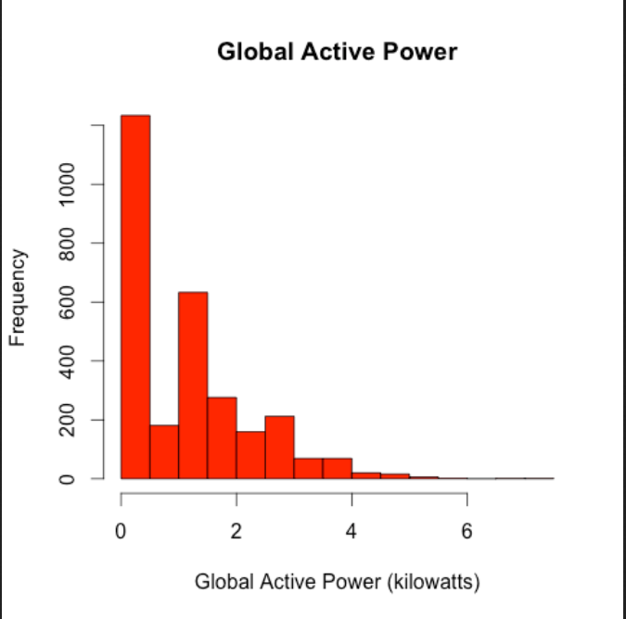

library(lubridate)

data <- read.csv('household_power_consumption.txt',header=TRUE,stringsAsFactors=FALSE,sep=';')

data <- data[data$Date %in% c("1/2/2007", "2/2/2007"), ]

dateTime <- as.POSIXlt(paste(as.Date(data$Date, format="%d/%m/%Y"), data$Time, sep=" "))

plot(dateTime, data$Global_active_power, ylab = "Global Active Power (kilowatts)", type = "l")

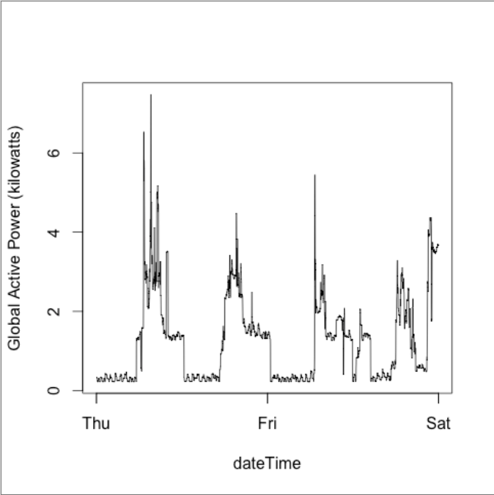

library(lubridate)

data <- read.table('household_power_consumption.txt',header=TRUE,stringsAsFactors=FALSE,sep=';')

data <- data[data$Date %in% c("1/2/2007", "2/2/2007"), ]

dateTime <- as.POSIXlt(paste(as.Date(data$Date, format="%d/%m/%Y"), data$Time, sep=" "))

plot(dateTime, data$Sub_metering_1, ylab ="Energy sub metering", type = "l")

lines(dateTime, data$Sub_metering_2, type = "l", col = "red")

lines(dateTime, data$Sub_metering_3, type = "l", col = "blue")

legend("topright", lwd = 2, legend = c("Sub_metering_1", "Sub_metering_2", "Sub_metering_3"), col = c("black", "red", "blue"))

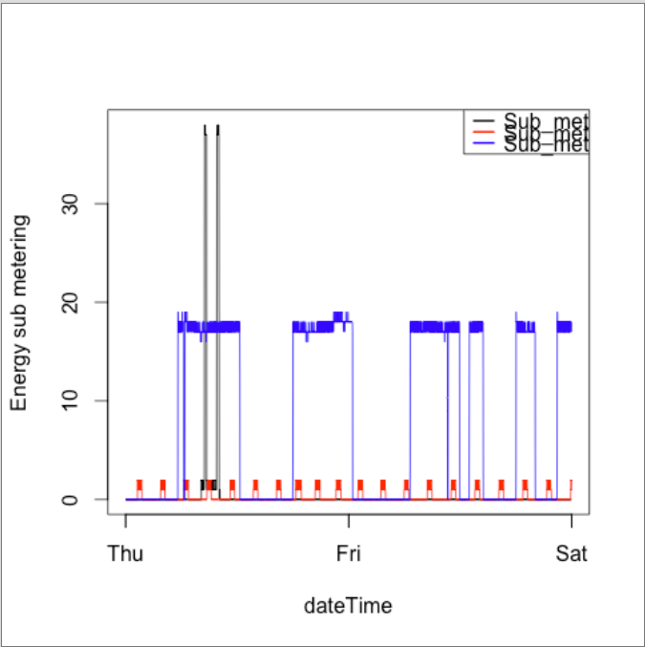

library(lubridate)

data <- read.table('household_power_consumption.txt',header=TRUE,stringsAsFactors=FALSE,sep=';')

data <- data[data$Date %in% c("1/2/2007", "2/2/2007"), ]

dateTime <- as.POSIXlt(paste(as.Date(data$Date, format="%d/%m/%Y"), data$Time, sep=" "))

par(mfrow = c(2, 2))

with(data, {

plot(dateTime, data$Global_active_power, ylab = "Global Active Power", type = "l")

plot(dateTime, data$Voltage, ylab = "Voltage", type = "l")

plot(dateTime, data$Sub_metering_1, ylab = "Energy sub metering", type = "l")

lines(dateTime, data$Sub_metering_2, type = "l", col = "red")

lines(dateTime, data$Sub_metering_3, type = "l", col = "blue")

legend("topright", lwd = 2, legend = c("Sub Metering 1", "Sub Metering 2", "Sub Metering 3"), col = c("black", "red", "blue"))

plot(dateTime, data$Global_reactive_power, ylab = "Global_reactive_power", type = "l")

})

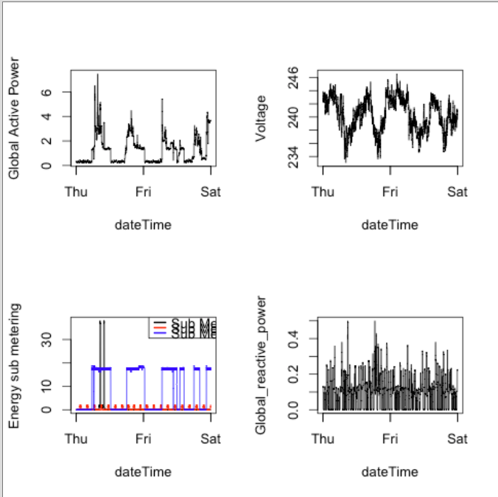

-------------------------------------------------------------- SECOND SUBMISSION --------------------------------------------------------------

## edit the file to provide full path to the unzipped data file and save it

## run with source("plot1.R")

path<-"data/household_power_consumption.txt" #where the data file is, make sure it is the unzipped version

dat<-read.csv(file=path,sep=";",na.strings = "?",skip=66637,nrows=2880, header = FALSE) #read only the rows corresponding to 2007-02-01 and 2007-02-02

colnames(dat)<-c("Date","Time","Global_active_power","Global_reactive_power","Voltage","Global_intensity","Sub_metering_1","Sub_metering_2","Sub_metering_3") #set the column names since we skipped the header

png(filename = "plot1.png", width = 480, height = 480) #create a png device for the plot

par(bg=NA) #make background transparent like the example image

hist(dat$Global_active_power, col="red", main="Global Active Power", xlab = "Global Active Power (kilowatts)") #create a histogram of Global Active Power

dev.off() #close the png file

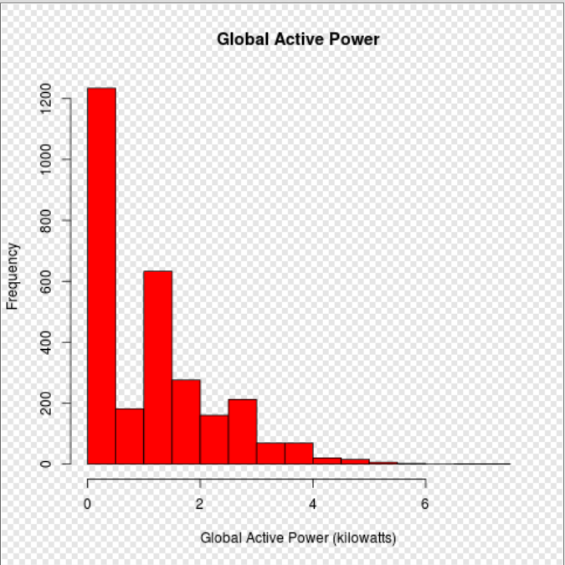

## edit the file to provide full path to the unzipped data file and save it

## run with source("plot2.R")

path<-"data/household_power_consumption.txt" #where the data file is, make sure it is the unzipped version

dat<-read.csv(file=path,sep=";",na.strings = "?",skip=66637,nrows=2880, header = FALSE) #read only the rows corresponding to 2007-02-01 and 2007-02-02

colnames(dat)<-c("Date","Time","Global_active_power","Global_reactive_power","Voltage","Global_intensity","Sub_metering_1","Sub_metering_2","Sub_metering_3") #set the column names since we skipped the header

x<-as.POSIXlt(strptime(paste(dat$Date,dat$Time,sep=" "),"%d/%m/%Y %H:%M:%S")) #create a vector of POSIXlt dates by combining the date and time columns

png(filename = "plot2.png", width = 480, height = 480) #create a png device for the plot

par(bg=NA) #make background transparent like the example image

plot(x,dat$Global_active_power, type = "n", ylab = "Global Active Power (kilowatts)", xlab="") #create the plot without data

lines(x,dat$Global_active_power) #plot the data as lines

dev.off() #close the png file

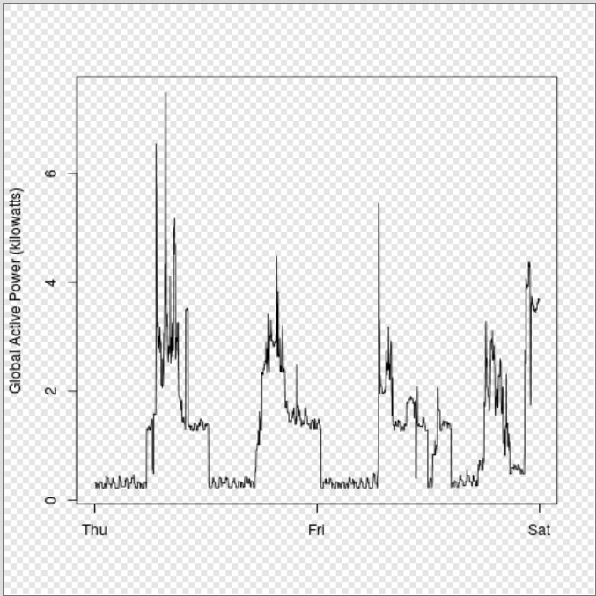

## edit the file to provide full path to the unzipped data file and save it

## run with source("plot3.R")

path<-"data/household_power_consumption.txt" #where the data file is, make sure it is the unzipped version

dat<-read.csv(file=path,sep=";",na.strings = "?",skip=66637,nrows=2880, header = FALSE) #read only the rows corresponding to 2007-02-01 and 2007-02-02

colnames(dat)<-c("Date","Time","Global_active_power","Global_reactive_power","Voltage","Global_intensity","Sub_metering_1","Sub_metering_2","Sub_metering_3") #set the column names since we skipped the header

x<-as.POSIXlt(strptime(paste(dat$Date,dat$Time,sep=" "),"%d/%m/%Y %H:%M:%S")) #create a vector of POSIXlt dates by combining the date and time columns

png(filename = "plot3.png", width = 480, height = 480) #create a png device for the plot

par(bg=NA) #make background transparent like the example image

plot(x,dat$Sub_metering_1, type = "n", ylab = "Energy sub metering", xlab="") #create the plot without data

lines(x,dat$Sub_metering_1, col="black") #plot Sub_metering_1 data as black lines

lines(x,dat$Sub_metering_2, col="red") #plot Sub_metering_2 data as red lines

lines(x,dat$Sub_metering_3, col="blue") #plot Sub_metering_3 data as red lines

legend("topright", legend=c("Sub_metering_1", "Sub_metering_2", "Sub_metering_3"), col=c("black","red", "blue"), lwd=c(1,1,1), cex=0.9) #create the legend, the cex parameter scales the legend text down

dev.off() #close the png file

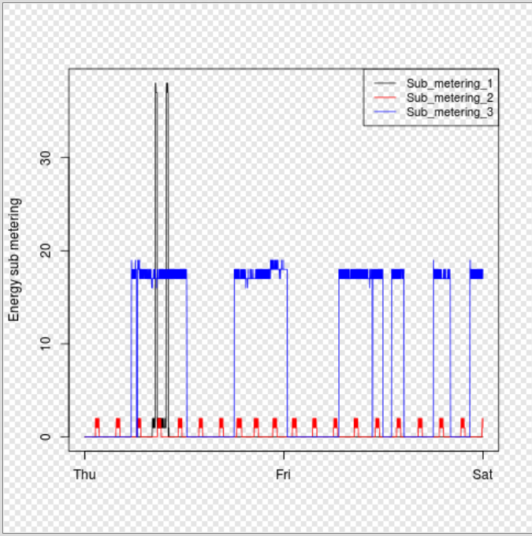

## edit the file to provide full path to the unzipped data file and save it

## run with source("plot2.R")

path<-"data/household_power_consumption.txt" #where the data file is, make sure it is the unzipped version

dat<-read.csv(file=path,sep=";",na.strings = "?",skip=66637,nrows=2880, header = FALSE) #read only the rows corresponding to 2007-02-01 and 2007-02-02

colnames(dat)<-c("Date","Time","Global_active_power","Global_reactive_power","Voltage","Global_intensity","Sub_metering_1","Sub_metering_2","Sub_metering_3") #set the column names since we skipped the header

x<-as.POSIXlt(strptime(paste(dat$Date,dat$Time,sep=" "),"%d/%m/%Y %H:%M:%S")) #create a vector of POSIXlt dates by combining the date and time columns

png(filename = "plot4.png", width = 480, height = 480) #create a png device for the plot

par(bg=NA) #make background transparent like the example image

par(mfrow=c(2,2))

plot(x,dat$Global_active_power, type = "n", ylab = "Global Active Power", xlab="") #create the plot without data

lines(x,dat$Global_active_power) #plot the data as lines

plot(x,dat$Voltage, type="n", ylab="Voltage", xlab="datetime")

lines(x,dat$Voltage)

plot(x,dat$Sub_metering_1, type = "n", ylab = "Energy sub metering", xlab="") #create the plot without data

lines(x,dat$Sub_metering_1, col="black") #plot Sub_metering_1 data as black lines

lines(x,dat$Sub_metering_2, col="red") #plot Sub_metering_2 data as red lines

lines(x,dat$Sub_metering_3, col="blue") #plot Sub_metering_3 data as red lines

legend("topright", border="none", legend=c("Sub_metering_1", "Sub_metering_2", "Sub_metering_3"), col=c("black","red", "blue"), lwd=c(1,1,1), cex=0.9, bty="n") #create the legend, the cex parameter scales the legend text down

plot(x,dat$Global_reactive_power, type="n", ylab="Global_reactive_power", xlab="datetime")

lines(x,dat$Global_reactive_power)

dev.off() #close the png file

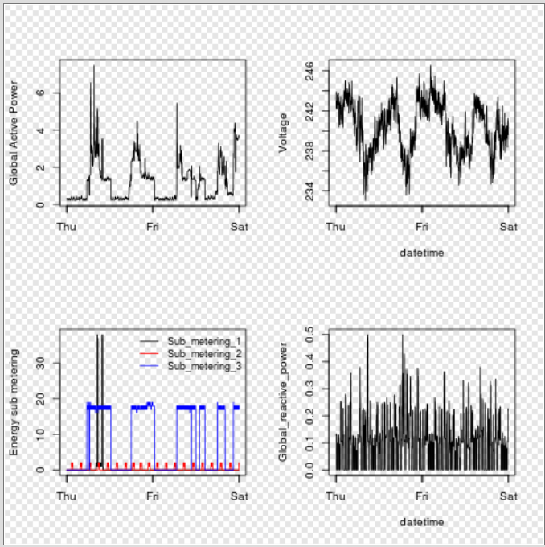

-------------------------------------------------------------- THIRD SUBMISSION --------------------------------------------------------------

# Plot1.r

setwd("C:/Documents and Settings/brian.robinson/ExData_Plotting1")

classes<-c(rep("character",2),rep("numeric",7))

pow<-read.table("household_power_consumption.txt",sep=";",header=T,stringsAsFactors=F,na.strings="?",colClasses=classes)

# re-class the date column

pow$Date<-as.Date(pow$Date,format="%d/%m/%Y")

# subset out the 2 days of data we want to work with

df<-pow[pow$Date %in% as.Date(c('2007-02-01','2007-02-02')),]

# prepare plot params and graph it

png(file="plot1.png",width = 480, height = 480)

with(df,hist(Global_active_power,col="red",main="Global Active Power",xlab="Global Active Power (kilowatts)"))

dev.off()

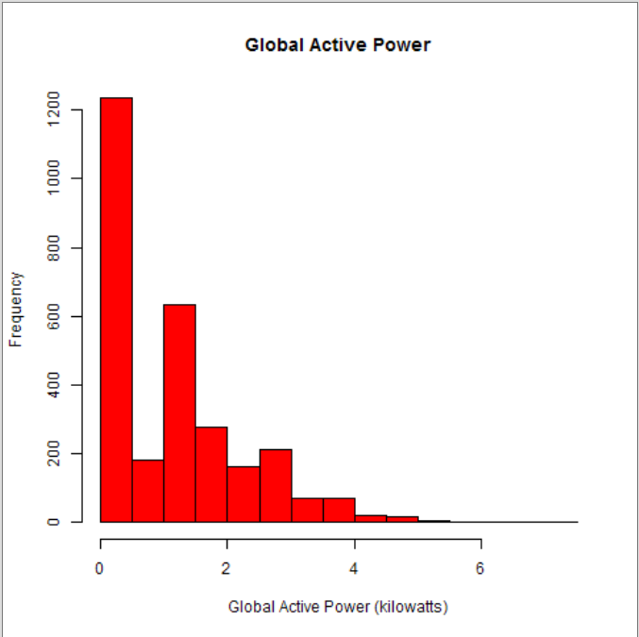

# Plot2.r

setwd("C:/Documents and Settings/brian.robinson/ExData_Plotting1")

classes<-c(rep("character",2),rep("numeric",7))

pow<-read.table("household_power_consumption.txt",sep=";",header=T,stringsAsFactors=F,na.strings="?",colClasses=classes)

# re-class the date column

pow$Date<-as.Date(pow$Date,format="%d/%m/%Y")

# subset out the 2 days of data we want to work with

df<-pow[pow$Date %in% as.Date(c('2007-02-01','2007-02-02')),]

# prepare plot params and graph it

png(file="plot2.png",width = 480, height = 480)

with(df,plot(Global_active_power,type="l",ylab="Global active power (kilowatts)",xaxt="n",xlab=""))

axis(1,c(1,1440,2880),c("Thu","Fri","Sat"))

dev.off()

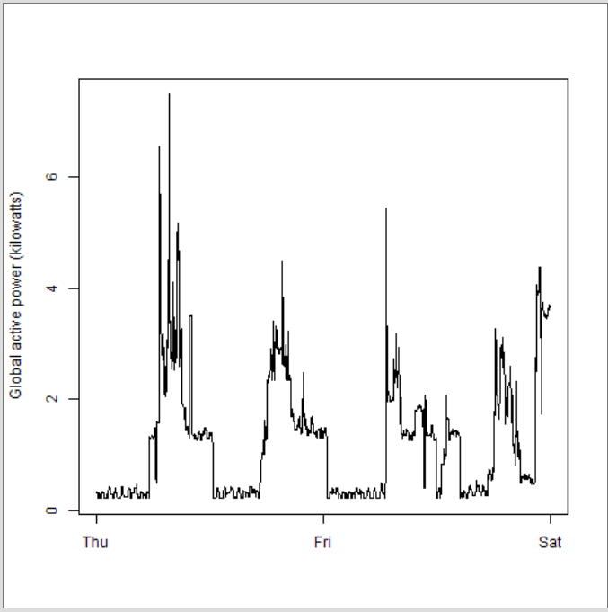

# Plot3.r

classes<-c(rep("character",2),rep("numeric",7))

pow<-read.table("household_power_consumption.txt",sep=";",header=T,stringsAsFactors=F,na.strings="?",colClasses=classes)

# re-class the date column

pow$Date<-as.Date(pow$Date,format="%d/%m/%Y")

# subset out the 2 days of data we want to work with

df<-pow[pow$Date %in% as.Date(c('2007-02-01','2007-02-02')),]

# prepare plot params and graph it

png(file="plot3.png",width = 480, height = 480)

par(mar=c(4,4,2,1))

attach(df)

plot(Sub_metering_1,type="l",ylab="Energy sub metering",xaxt="n",xlab="")

lines(Sub_metering_2,col="red")

lines(Sub_metering_3,col="blue")

legend("topright",col=c("black","red","blue"),legend=c("Sub_metering_1","Sub_metering_2","Sub_metering_3"),pch="____")

axis(1,c(1,1440,2880),c("Thu","Fri","Sat"))

dev.off()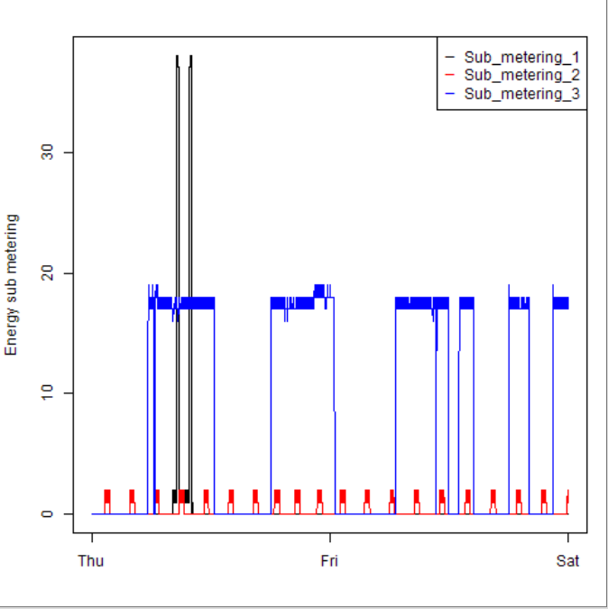

# Plot4.r

# set up the classes to speed up the read.table op

classes<-c(rep("character",2),rep("numeric",7))

pow<-read.table("household_power_consumption.txt",sep=";",header=T,stringsAsFactors=F,na.strings="?",colClasses=classes)

# re-class the date column

pow$Date<-as.Date(pow$Date,format="%d/%m/%Y")

# subset out the 2 days of data we want to work with

df<-pow[pow$Date %in% as.Date(c('2007-02-01','2007-02-02')),]

# prepare plot params and graph it

png(file="plot4.png",width = 480, height = 480)

par(mfrow=c(2,2))

with(df,plot(Global_active_power,ylab="Global Active Power",xaxt="n",type="l",xlab=""))

axis(1,c(1,1440,2880),c("Thu","Fri","Sat"))

plot(Voltage,ylab="Voltage",xlab="datetime",xaxt="n",type="l")

axis(1,c(1,1440,2880),c("Thu","Fri","Sat"))

plot(Sub_metering_1,type="l",ylab="Energy sub metering",xaxt="n",xlab="")

lines(Sub_metering_2,col="red")

lines(Sub_metering_3,col="blue")

legend("topright",col=c("black","red","blue"),legend=c("Sub_metering_1","Sub_metering_2","Sub_metering_3"),pch="___")

axis(1,c(1,1440,2880),c("Thu","Fri","Sat"))

plot(Global_reactive_power,xaxt="n",type="l",xlab="datetime")

axis(1,c(1,1440,2880),c("Thu","Fri","Sat"))

dev.off()

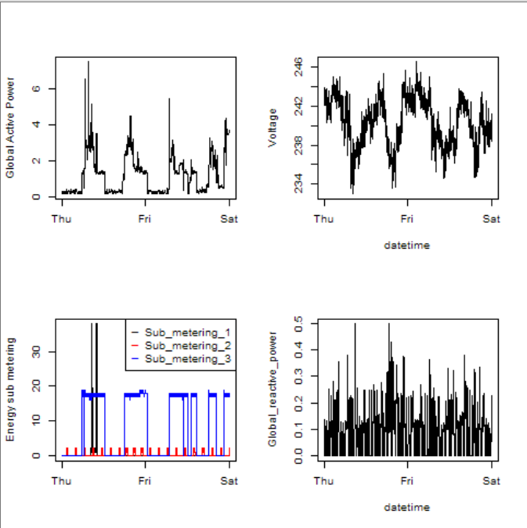

-------------------------------------------------------------- FOURTH SUBMISSION --------------------------------------------------------------

dataFile <- "household_power_consumption.txt"

data <- read.table(dataFile, header=TRUE, sep=";", stringsAsFactors=FALSE, dec=".")

subSetData <- data[data$Date %in% c("1/2/2007","2/2/2007") ,]

#str(subSetData)

globalActivePower <- as.numeric(subSetData$Global_active_power)

png("plot1.png", width=480, height=480)

hist(globalActivePower, col="red", main="Global Active Power", xlab="Global Active Power (kilowatts)")

dev.off()

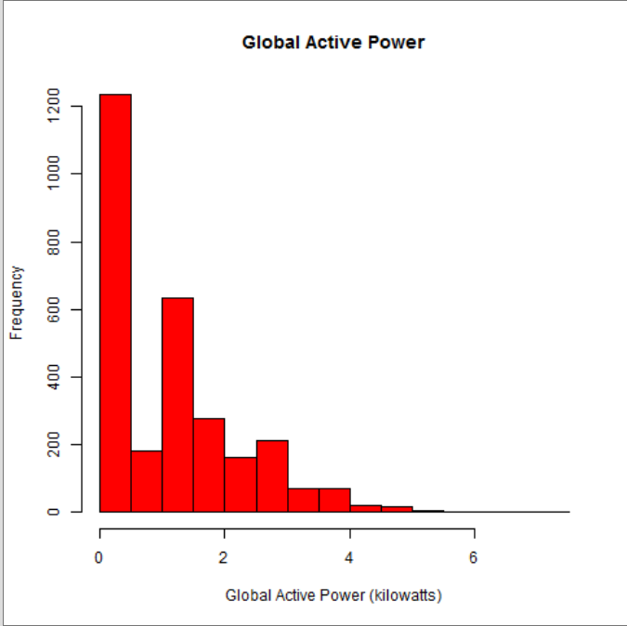

dataFile <- "household_power_consumption.txt"

data <- read.table(dataFile, header=TRUE, sep=";", stringsAsFactors=FALSE, dec=".")

subSetData <- data[data$Date %in% c("1/2/2007","2/2/2007") ,]

#str(subSetData)

datetime <- strptime(paste(subSetData$Date, subSetData$Time, sep=" "), "%d/%m/%Y %H:%M:%S")

globalActivePower <- as.numeric(subSetData$Global_active_power)

png("plot2.png", width=480, height=480)

plot(datetime, globalActivePower, type="l", xlab="", ylab="Global Active Power (kilowatts)")

dev.off()

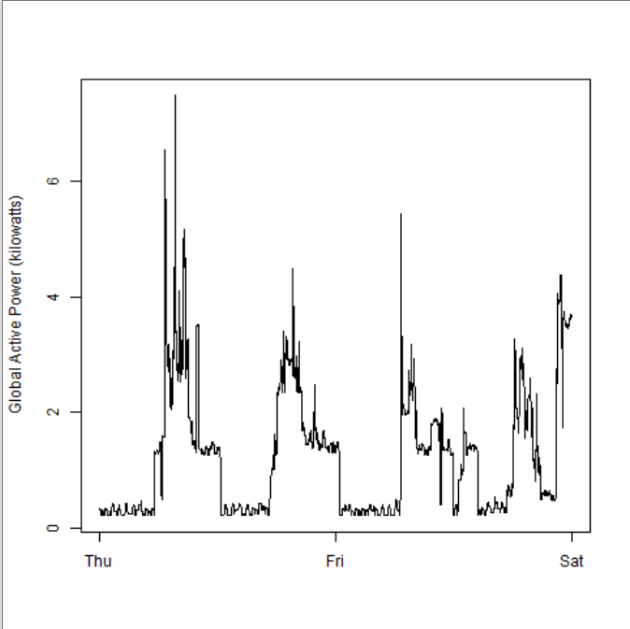

dataFile <- "household_power_consumption.txt"

data <- read.table(dataFile, header=TRUE, sep=";", stringsAsFactors=FALSE, dec=".")

subSetData <- data[data$Date %in% c("1/2/2007","2/2/2007") ,]

#str(subSetData)

datetime <- strptime(paste(subSetData$Date, subSetData$Time, sep=" "), "%d/%m/%Y %H:%M:%S")

globalActivePower <- as.numeric(subSetData$Global_active_power)

subMetering1 <- as.numeric(subSetData$Sub_metering_1)

subMetering2 <- as.numeric(subSetData$Sub_metering_2)

subMetering3 <- as.numeric(subSetData$Sub_metering_3)

png("plot3.png", width=480, height=480)

plot(datetime, subMetering1, type="l", ylab="Energy Submetering", xlab="")

lines(datetime, subMetering2, type="l", col="red")

lines(datetime, subMetering3, type="l", col="blue")

legend("topright", c("Sub_metering_1", "Sub_metering_2", "Sub_metering_3"), lty=1, lwd=2.5, col=c("black", "red", "blue"))

dev.off()

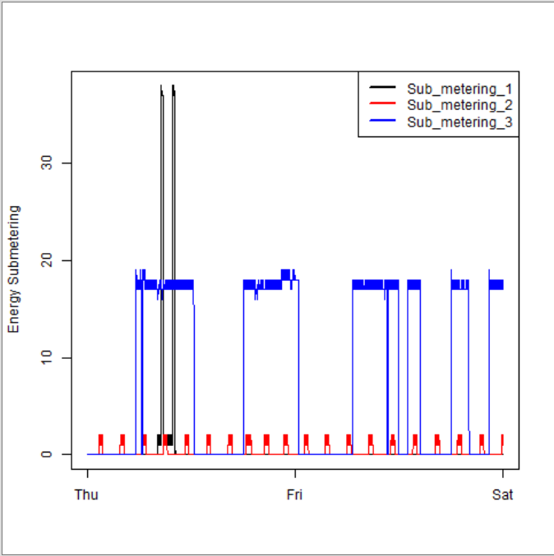

dataFile <- "household_power_consumption.txt"

data <- read.table(dataFile, header=TRUE, sep=";", stringsAsFactors=FALSE, dec=".")

subSetData <- data[data$Date %in% c("1/2/2007","2/2/2007") ,]

#str(subSetData)

datetime <- strptime(paste(subSetData$Date, subSetData$Time, sep=" "), "%d/%m/%Y %H:%M:%S")

globalActivePower <- as.numeric(subSetData$Global_active_power)

globalReactivePower <- as.numeric(subSetData$Global_reactive_power)

voltage <- as.numeric(subSetData$Voltage)

subMetering1 <- as.numeric(subSetData$Sub_metering_1)

subMetering2 <- as.numeric(subSetData$Sub_metering_2)

subMetering3 <- as.numeric(subSetData$Sub_metering_3)

png("plot4.png", width=480, height=480)

par(mfrow = c(2, 2))

plot(datetime, globalActivePower, type="l", xlab="", ylab="Global Active Power", cex=0.2)

plot(datetime, voltage, type="l", xlab="datetime", ylab="Voltage")

plot(datetime, subMetering1, type="l", ylab="Energy Submetering", xlab="")

lines(datetime, subMetering2, type="l", col="red")

lines(datetime, subMetering3, type="l", col="blue")

legend("topright", c("Sub_metering_1", "Sub_metering_2", "Sub_metering_3"), lty=, lwd=2.5, col=c("black", "red", "blue"), bty="o")

plot(datetime, globalReactivePower, type="l", xlab="datetime", ylab="Global_reactive_power")

dev.off()

